# GIT Hub

In order to access the GitHub first the git bash must be downloaded and installed. It can be downloaded by using the following url

Girt bash downloads

<https://git-scm.com/downloads>

Create an account in the GitHub which is enclosed in the following url

Go to the [github.com](https://d.docs.live.net/763cb05081b054be/Desktop/github.com)

|  |  |  |
| --- | --- | --- |
| 1 | Git –version | To check versions |
| 2 | Git - -config user.name | Configures username |
| 3 | Git - -config user.email | Configures email |
| 4 | Git config - - list | Configures check username and email |
| 5 | Git config - -help | Git help |
| 6 | Pwd | Checks the access |
| 7 | Cd |  |
| 8 | Mkdir | Creates directory |
| 9 | Cd | Access directory |
| 10 | Ls | Displays files in directory |
| 11 | Git init | Empty repository |
| 12 | **g**it remote add origin with url copied | transforms the local folder to git folder |
| 13 | Git add | Adds the local folder to global folder |
| 14 | GIT COMMIT -M | Comits the files |
| 15 |  |  |
| 16 |  |  |

Create the account in the GitHub and after installing the the git bash open it

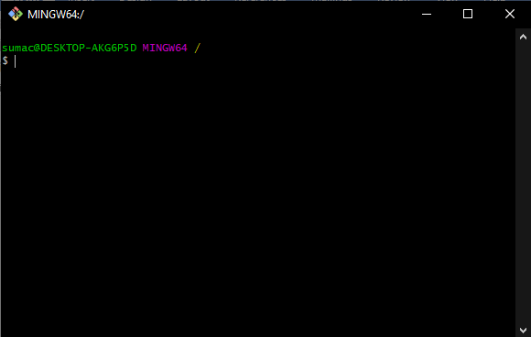

Commands to check the version of git anf git configuration

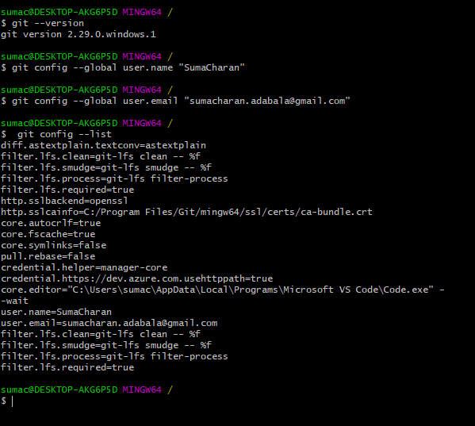

Type the Following commands as shown below

**Command: git help config, git config --help**

Command: **pwd**

Press enter

Command **: cd**

Press enter

See the enclosed screenshot

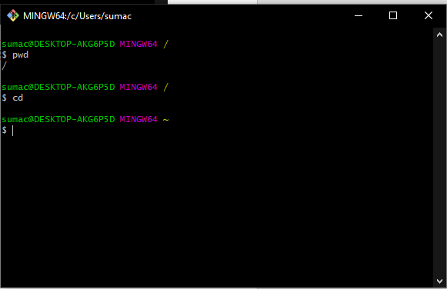

Create a directory named python

Command: **mkdir Pythondirectory**

Command: **Cd pythondirectory**

Command**: ls**

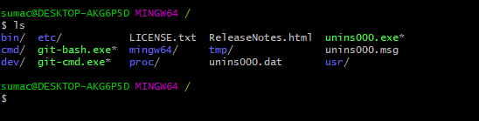

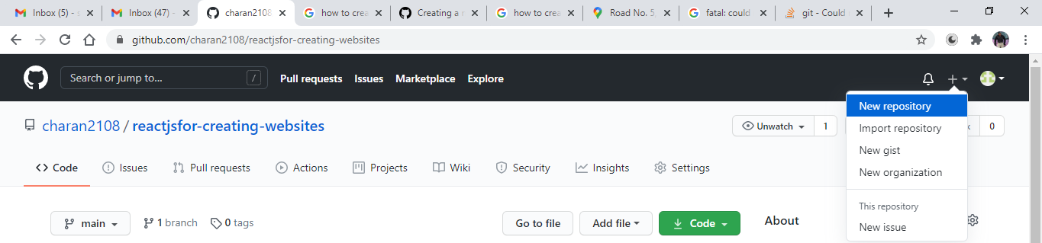

**Login into github after login on the right hand side there is a + symbol click on it there is option names as new repository click on it.After clicking on the repository a new page displays and as shown below.Enter the repository name as PythonDir.After entering the anme add the following**

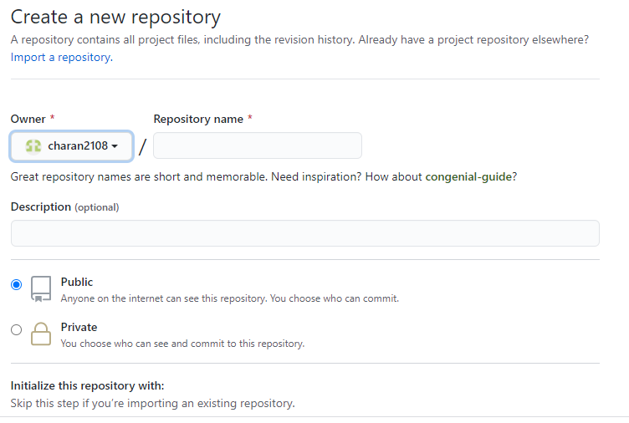

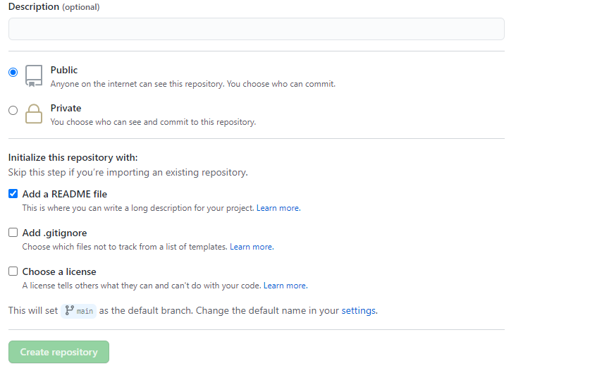

Click on the create repository and the following will be displayed. Click on the code and copy the following url

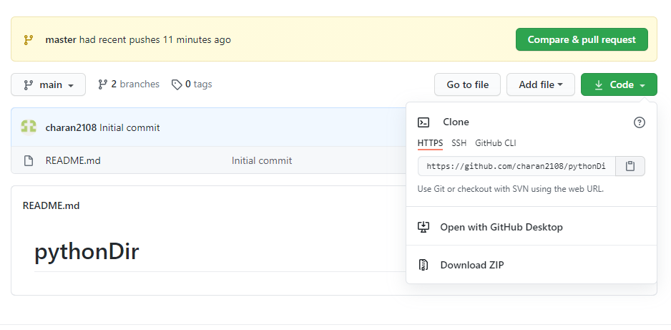

Click on the gitbash cmd and do the following

Before creating the git init we need to create a local folder named pythondirectory

**Mkdir pythondirectory**

**Cd pythondirectory**

Creating the git init from the git bash

Command: **git init**

Press enter

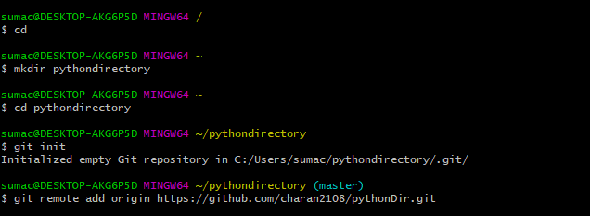

After initializing the init file add the following command to

Command:  **git remote add origin with url copied**

Next add the files in the local `folder to the external by using the

Command: **git add.**

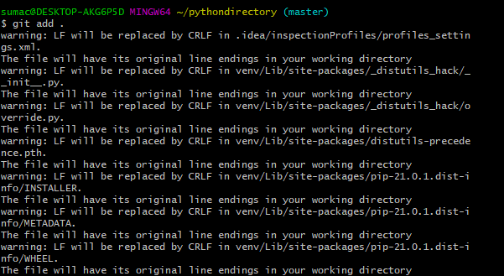

We are going to commit the files by the command

**Git commit -m “First commit”**

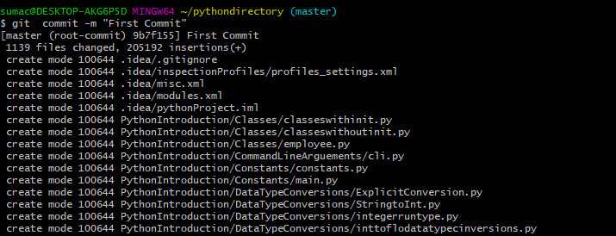

Saving the files in the github

**Command: git push origin master**



 